Following Udemy course GitLab CI/CD: Pipelines, CI/CD and DevOps for Beginners by Valentin Despa
Introduction
- CI/CD: Continuous Integration and Continuous Deployment
- Will take a website, build it, test it, and deploy to AWS
- CI – integrate and build new version, and CD – deploy
- Goal: to eliminate manual, repetitive work
- GitLab – devops platform, Git: code version control. Can define pipelines with their CI/CD (compiles, runs tests, creates a new version of software, and deploys to server)

Create simple CI/CD Job
- Log into GitLab, go into Web IDE > create file > naming starts with “.gitlab”
- 
- 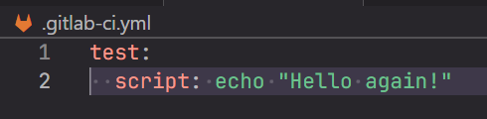
- Commit to main
- 